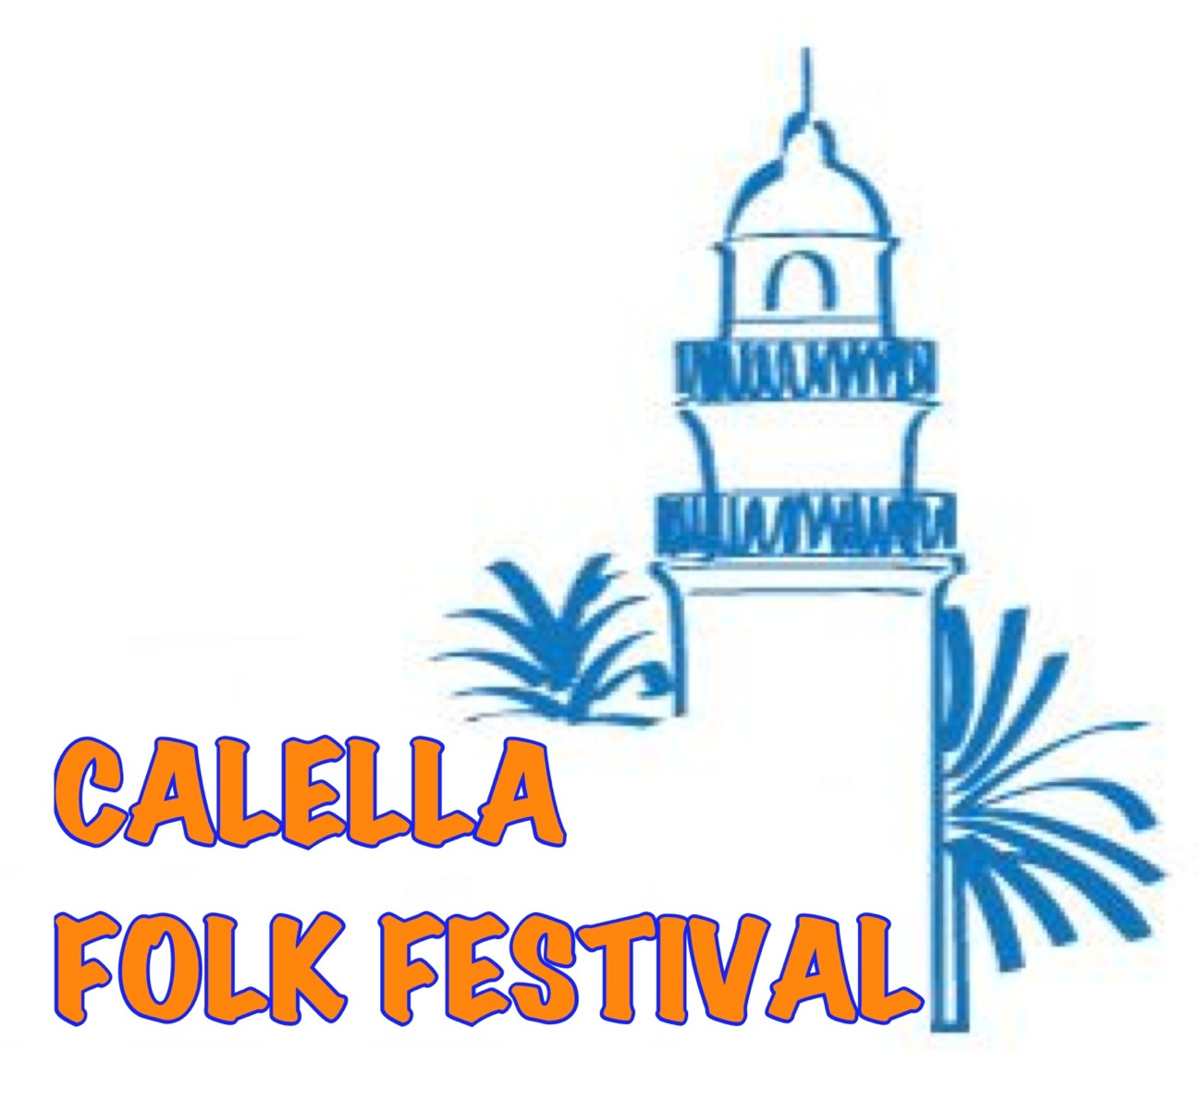
IX Internacional CALELLA FOLK FESTIVAL 2018
Calella - Spain
from 16th to 23rd June 2018
or
from 23rd to 30th June 2018

A P P L I C A T I O N F O R M

Full name of the ensemble:

Group Leader:

Address/Country:

Number of participants: Total:

Male: Female: Drivers: Adult (18+):

Contact phone number:

Mobile phone number:

Fax:

E-mail:

Acceptance Statement: I confirm that I have read and accept the festival conditions.

Date:

Signature of the responsible person: ________________________

* * * W E L C O M E * * *

FORTUNI VIATGES
C/Tamarit 120, local 08015 Barcelona
Tel.: +34 93 289 21 38 Fax: +34 93 289 21 39
E-mail: folk@fortuniviatges.com www.calellafolkfestival.com

