XVIII INTERNATIONAL FESTIVAL FOLKLORE
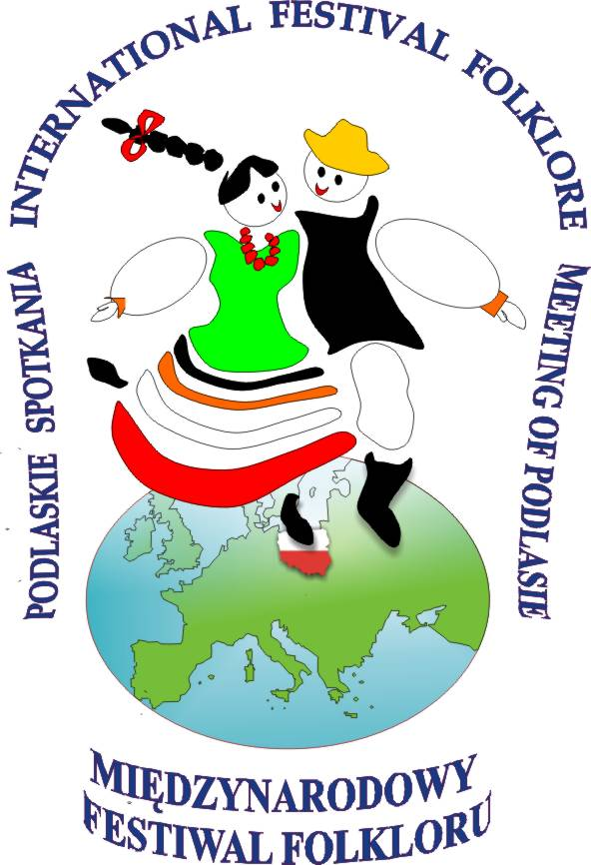

„MEETING of PODLASIE”

„PODLASKIE SPOTKANIA”

01.08 – 07.08. 2023.

www.podlasie-festival.letnet.pl
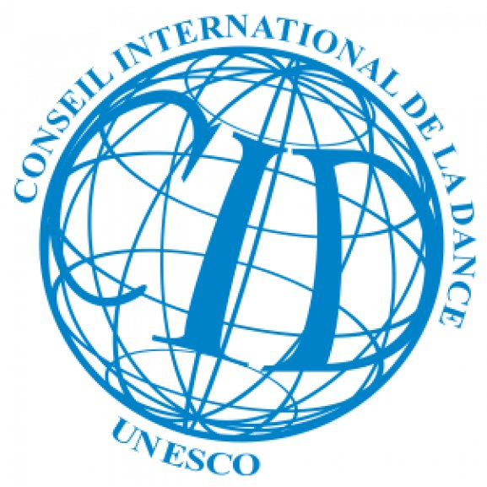
podlasie.festival@wp.pl

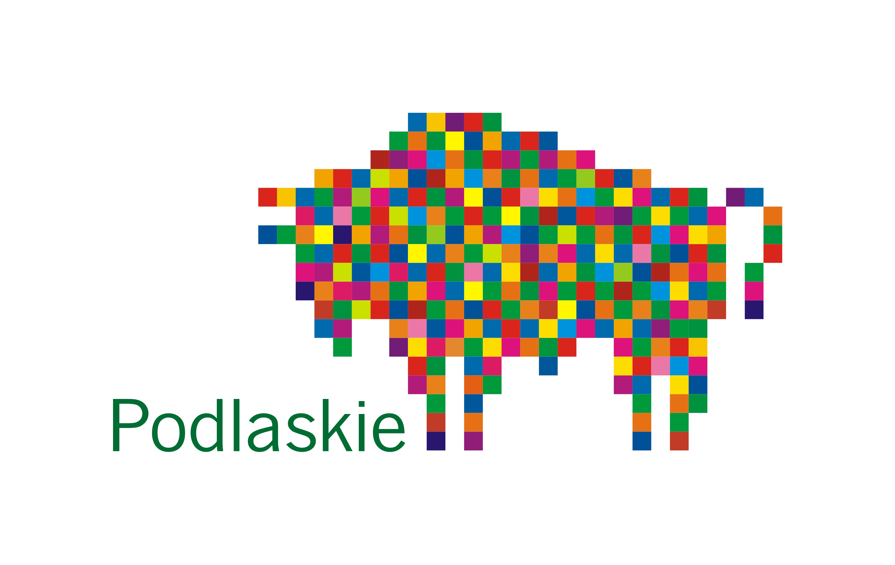

APPLICATION FORM

- Name of the Ensemble ……………………………………………………………………………………………….

We declare participation in International Festival Folklore
,,Meeting of Podlasie” ( 01- 07 August 2023 )
and we oblige ourselves to respect its regulations.

............................................................................................................................................
Director of the Ensemble

- Country ……………………………………………………………………………………………………………………………………………...

Name of patronage institution ……………………………………………………………………………………………….

- Name of the Director ...................................................................................................................

Private e-mail ( if possible) ………………………………………………………………………………………………………………

E-mail ………………………………………………………………………………………………………………………………………………….

- Official address of Ensemble: Street ……………………………………………………………………………………..

Postcode …………………………………… City / Town ………………………………………………………………………………..

Fax ………………………………………………….. E-mail …………………………………………………………………………………….

http:// ………………………………………………………………………………………………………………………………………………….

YouTube …………………………………………………………………………………………………………………………………………………

- Total number of participants 25 Female ………….. Male: ................................

(Including the music group: ....................... and accompanying persons ....................................

- Language(s) used by the Ensemble: ......................................................................................

- Will you be coming with an interpreter ? ...........................................................................

- Your means of transport ............................................................................................................

- Other remarks for the organizers : .......................................................................................

11. Name of the Music Director: ....................................................................................................

- Name of the Choreographer: ................................................................................................................................................................

- We have prepared 2/3 choreographies in separate costumes

………………………………………………………………………………………………………………………
minimum program 15 minutes, max program duration up to 30 minutes.

Please enclose the printed materials with names of dances, songs , folk games and plays, Customs and the title of your programme ,
history of the Ensemble, information about participation in another festivals , a list of countries visited and awards won so far; as well as photographs , a music recording of the band and a link video .
Under the Data Protection Act (2018), we are required to inform you that the information you have provided will be held on computer for the sole use of the International Folk Festival Meeting of Podlasie.
Your details will not be passed on to any other company or organisation.
Applying to perform at the festival does not infer acceptance. We will contact you for more information if you are accepted.

Women / Girls |  |  | Men / Boys
L | Name , Surname | Date of birth | L | Name , Surname | Date of birth
1 |  |  | 1
2 |  |  | 2
3 |  |  | 3
4 |  |  | 4
5 |  |  | 5
6 |  |  | 6
7 |  |  | 7
8 |  |  | 8
9 |  |  | 9
10 |  |  | 10
11 |  |  | 11
12 |  |  | 12
13 |  |  | 13
14 |  |  | 14
15 |  |  | 15

Accompanying persons |  | Musicians
Name , Surname | Function | Name, Surname | Instrument

Attention. All qualifying groups must be vaccinated or tested negative for the Covid 19 test.

Technical Details / Rider /

Informations about group

