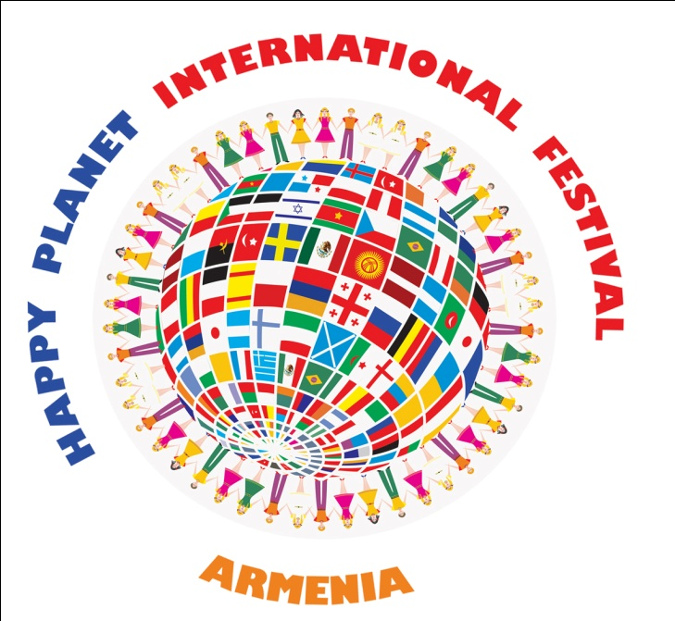
R e p u b l i c o f A r m e n i a
‘’D I s n e y’’ a r t s c h o o l
''A y g e k'' a r t s c h o o l a n d
M u n i c i p a l i t y o f T s a g h k a d z o r

INTERNATIONAL FESTIVAL ''HAPPY PLANET'' TSAGHKADZOR ARMENIA 14-20 JULY 2023
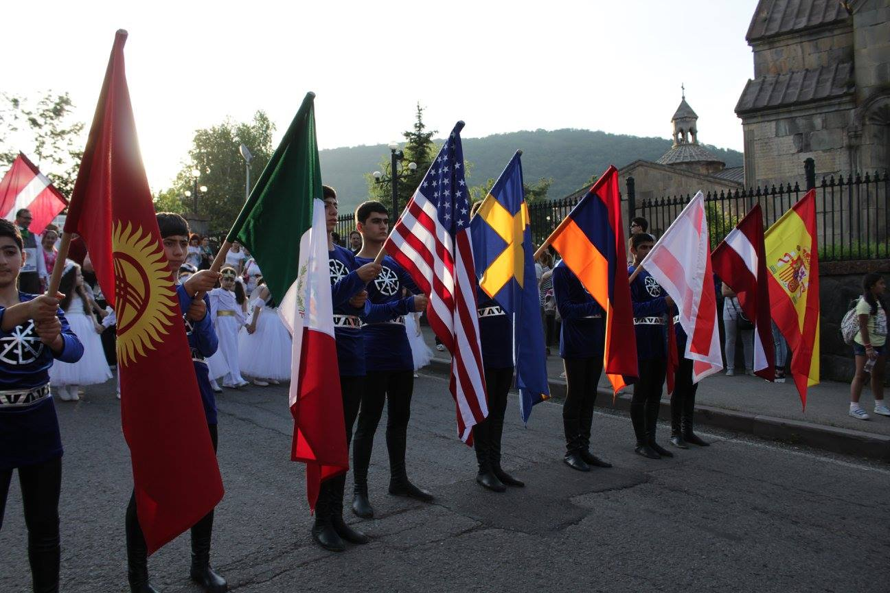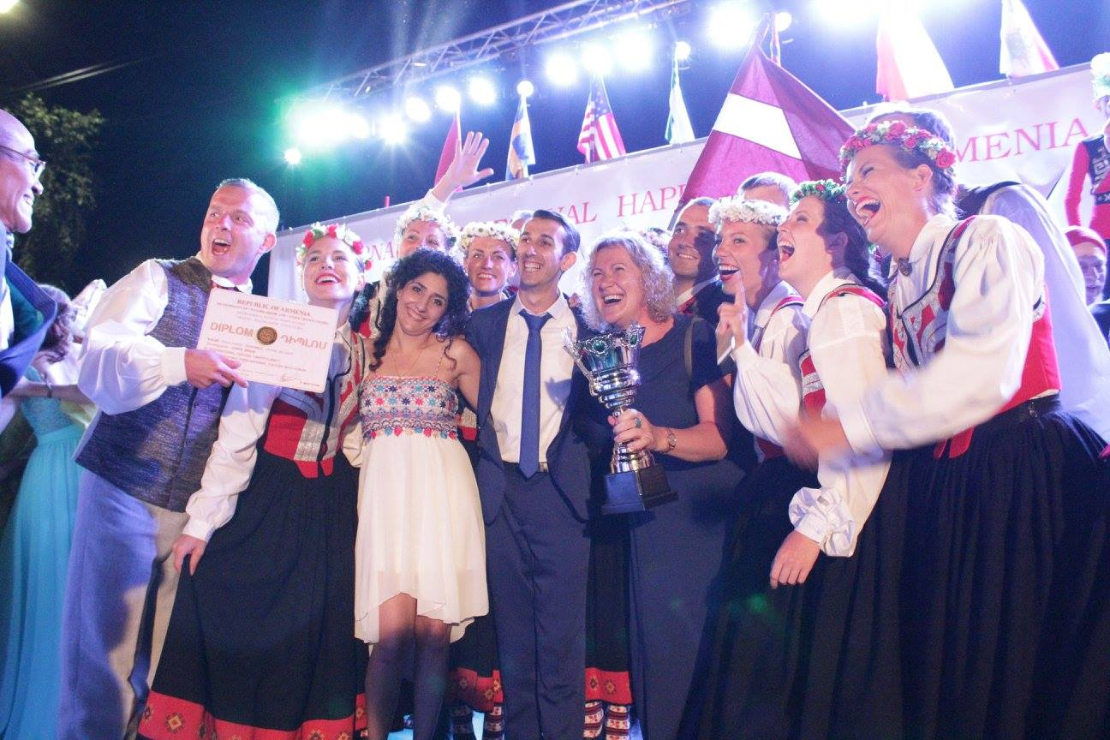
The organizators of festival are the municipality of Tsaghkadzor and '' Aygek'' art school .The festival is being held in Tsaghkadzor, which is considered a developed Armenia's tourist cities. The main purposes of festival is the cultural development , friendly relations between different nationalities and acquaintance, cultural exchange.
Groups, ensembles, individuals, solo, trio and quartet can participate in the festival.The festival consist of 2 parts: competitive and non- competitive. The Participants can take part in both if they want.
Festival sections
1. Choreography - folk, modern, latin, classic.
2. Song – folk, estrad, classic.
3. Painting
4. Musical instruments

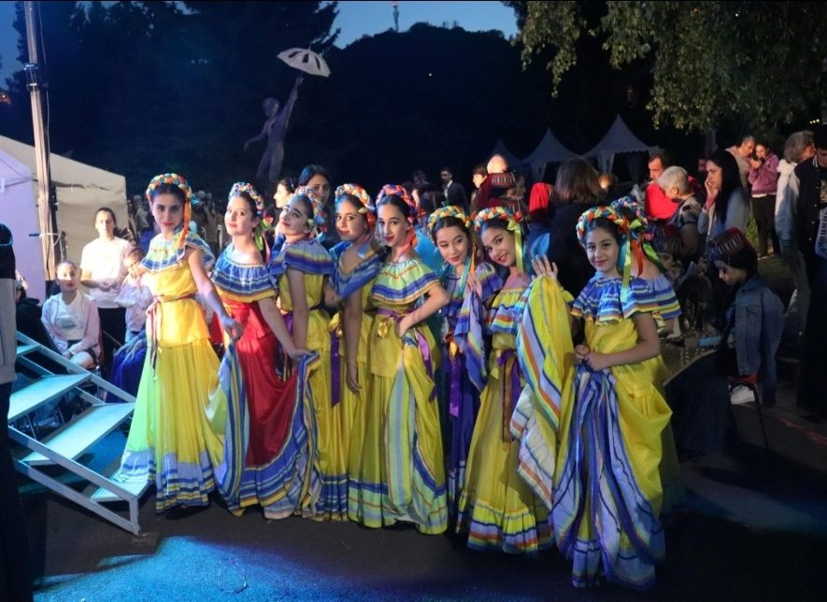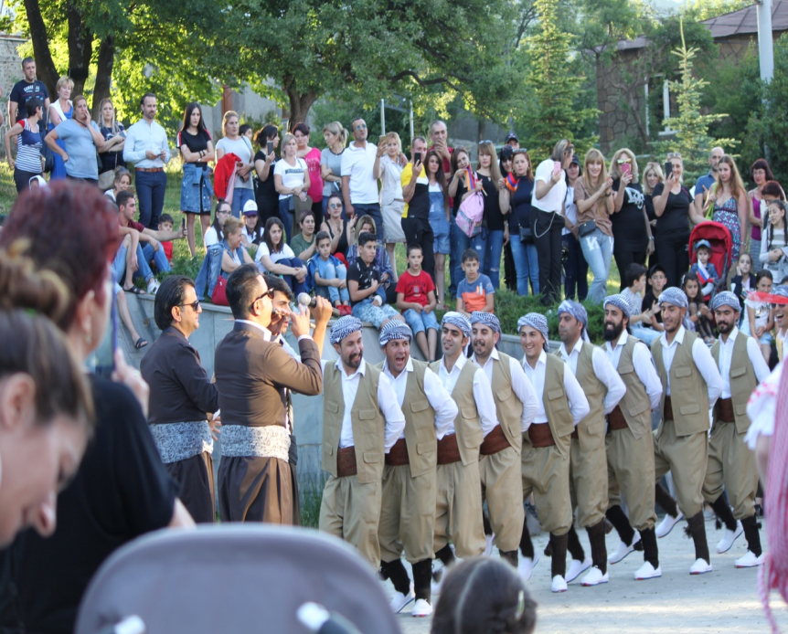
Age groups
- A group: 8-16 years old
- B group: 16 years and older

The jury of festival

The professional jury of festival will invite from different countries and they will assess the participants.

The Criterion of Appraisal

- The technique of performance
- The art of performance and (theatrical ) scenic mastery
- The costumes, used during the performance
- The singularity and originality of composition
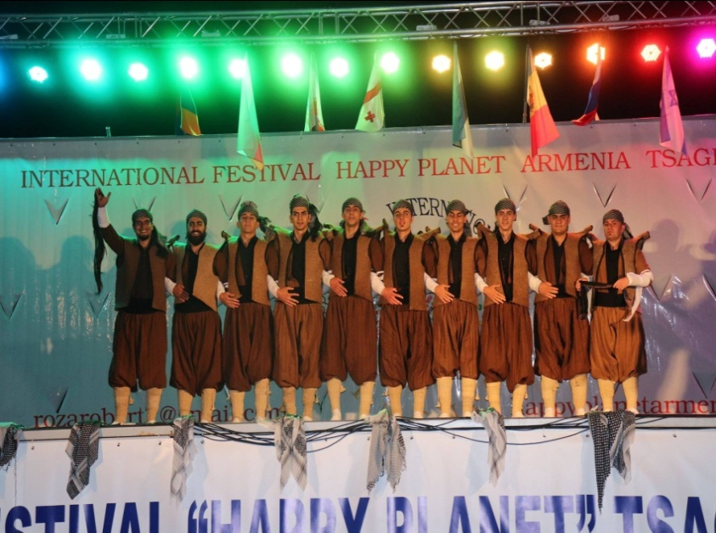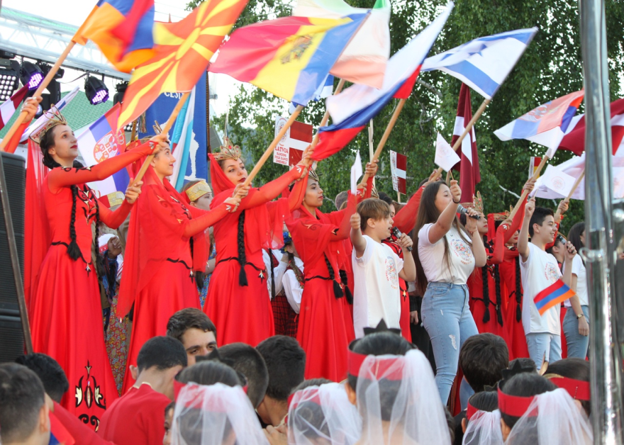

Program of festival
The festival starting with parad, national costumes and flag.
In time of parad every group should participate 1 national dance should have duration 2-3 minutes. The parad continue to the square of Tsaghkadzor, where should be the concert.
The first day the group should present 1 dance, which should have duration 5 minutes.
The second day competitive day the group should present 2 dances, each of them should have duration 5 minutes. Every dance with their costume.
The third day the award of prizes and Gala concert, in time the participants should present 1 composition. They should compete for Grand Prix.
The festival have 2 Grand Prix, one for age 8-15 year old and other for 16 years and older.
And exchange of national dances the other countries participants should teaching others their 1 national dance. The leaders and participants should have master class, which should spend the member’s of jury. They should get the international certificate.

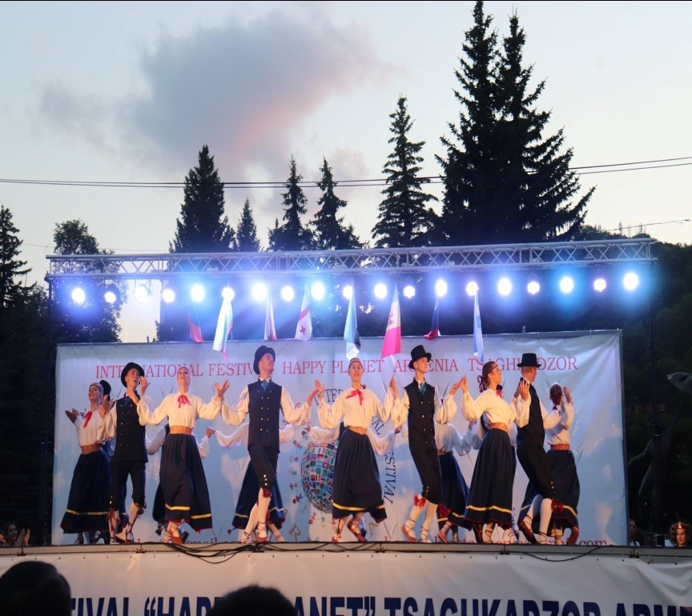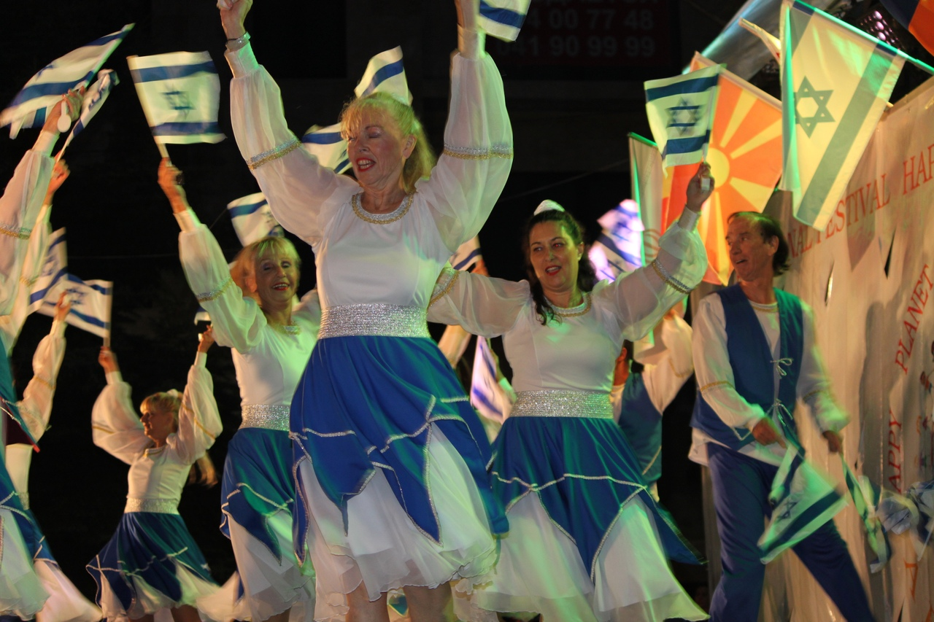
The participants will be awarded 1st 2 ^{nd} and 3rd places.
The best groups will be awarded in different nominations:
- The best dancing technique
- The best dancing ensemble
- The best scenic mastery
- The best performance
- The best music
- The best costume
- The sympathy of spectators

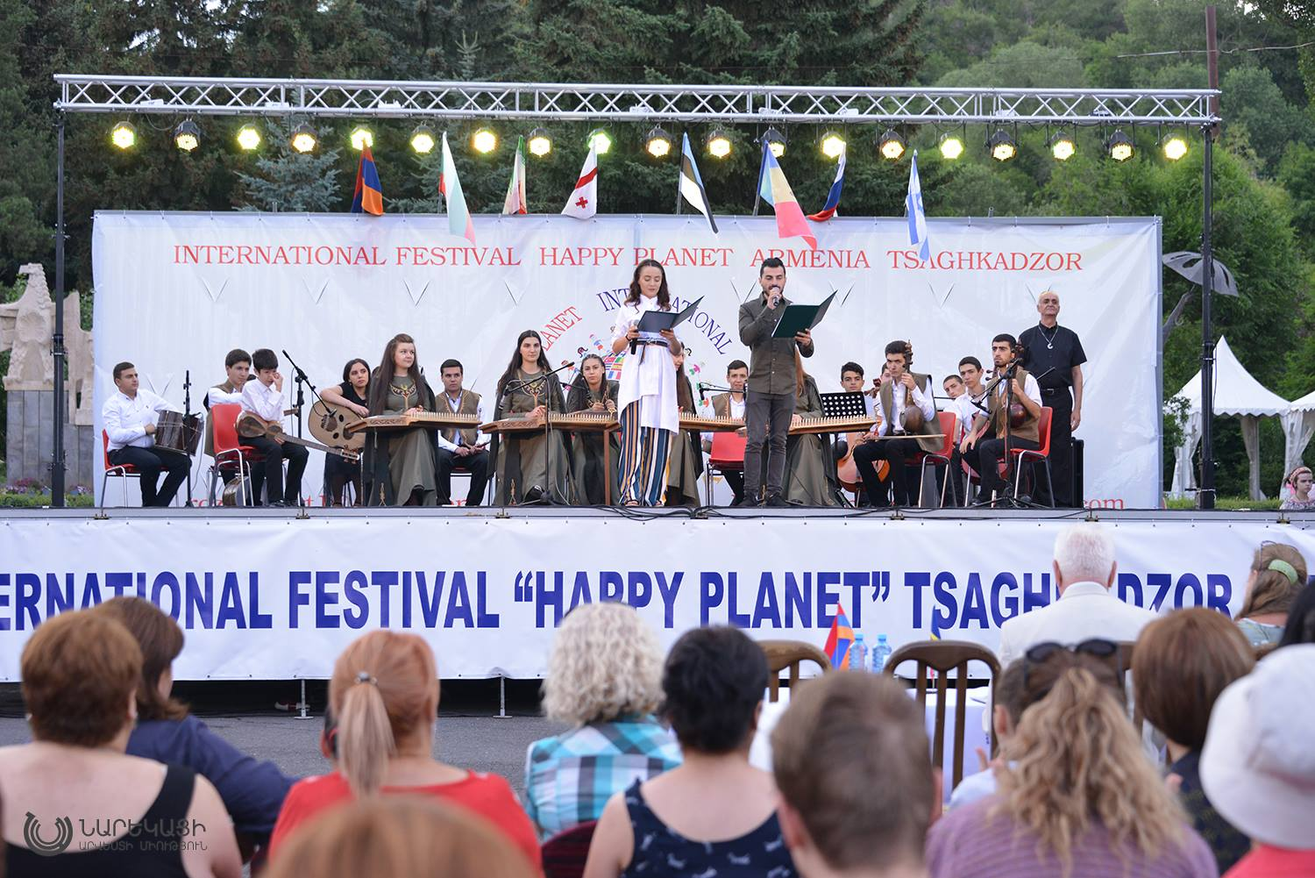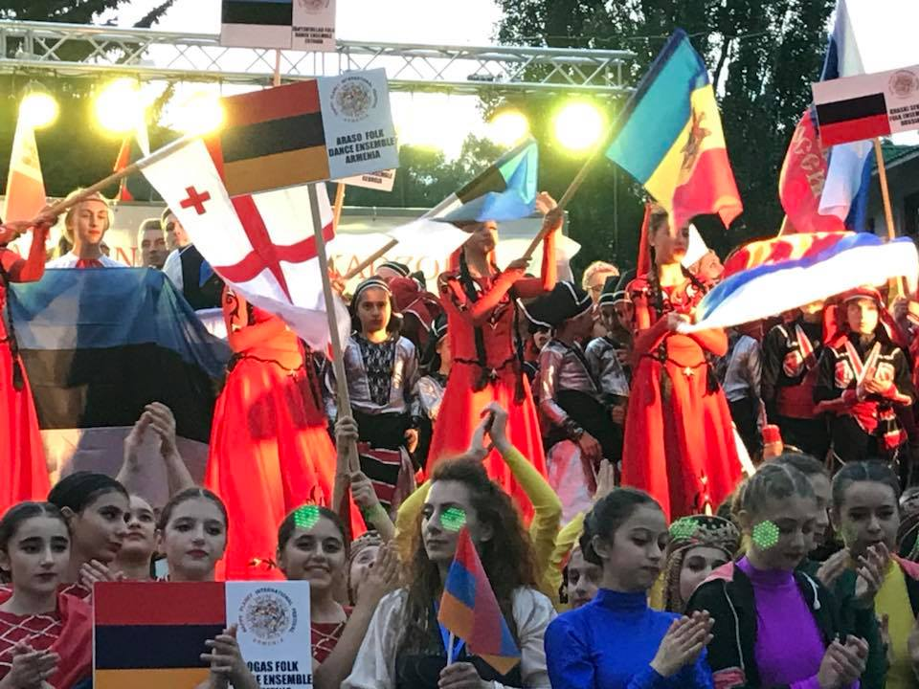

Festival participation fee
Per person - 190 euro, in this include 3*** hotel (6 night 7 day), breakfast, lunch and dinner . Excursion Lake Sevan
And the transfer from international airport ZVARTNOC to city Tsaghkadzor and back - 400 euro.
The participants should send 10% of payment deposit for hotels should paid in advance up to 31st of May, other when arrive.
Note: That group which will not send payment that group don’t accommodate in hotel.
Additional excursions
- Excursion to the Yerevan and in Cognac factory - 40 euro

- Dilijan (Hagharcin) - 15 euro

- Add excursion Lake Sevan – 5 euro

- Aqua park Yerevan – 30 euro
5.Yerevan park - 45 euro (attraction park)

The applications should be filled and sent by e- mail until 31 of May.
- happyplanetarmenia@gmail.com
- rozarobert1@gmail.com
-(+374)94425135 (+374)95262023 (+374)93964997 (+374)55823074
-WhatsApp / Viber (+374)95262023 (+374)93964997

